SUPPLEMENTAL MATERIAL

Evidence for maintenance of key components of vocal learning in aging budgerigars despite diminished affiliative social interaction

Bushra Moussaoui¹, Samantha L. Overcashier¹, Gregory M. Kohn², Marcelo Araya-Salas³, Timothy F. Wright¹

¹Department of Biology, New Mexico State University, Las Cruces, NM, USA
²Department of Psychology, University of North Florida, Jacksonville, FL, USA
³Centro de Investigación en Neurociencias & Escuela de Biología, Universidad de Costa Rica, San José, Costa Rica

Proceedings of the Royal Society B
Doi: 10.1098/rspb.2023.0365

Methods
- Contact call acoustics
Prior to assessing vocal learning, we tested whether contact calls of young and older adults differed with respect to each of the 17 acoustic parameters. We computed a mean value per individual for calls produced throughout the entire recording period for each parameter and compared this mean between the two age classes using an independent samples t-test for parameters exhibiting a normal distribution and homogeneity of variances. Parameters that failed to meet one or both assumptions were analyzed using a Mann-Whitney U test.

- Acoustic space generation using rarefaction
Since the size and shape of acoustic space can depend on the number of calls sampled, and we observed high individual variability in the number of contact calls produced during a recording block (ranging from 0 to 1,398 contact calls), all acoustic spaces were generated using a rarefaction subsampling procedure to be able to accurately draw comparisons across groups. Prior to subsampling, we only included recording blocks for each individual in which at least 6 contact calls were collected. Rarefaction then consisted of randomly resampling the same number of calls from each recording block per individual (using the minimum number of calls across these groups) for 30 iterations, resulting in each acoustic space containing 180 contact calls.

- Video coding
Social interactions were coded by two trained observers (B.M. and S.L.O.) and inter-observer reliability was assessed at “good” to “excellent” reliability (ICC = 0.972; 95% CI = [0.892, 0.993]) by employing a single-measurement, absolute-agreement two-way mixed-effects model using the package irr (version 0.84.1) in R version 4.0.5 (R Core Team, 2021).

- Social integration over time
For each network type, to assess whether age can predict changes in strength and density over time, we also fit GLMMs with additional fixed effects of recording half and the interaction between age class and recording half. For density over time analyses, experimental flock was added as a random effect to account for repeated measures by flock. Similarly, for strength over time analyses, individual identity was added as a random effect to account for repeated measures by individual bird. Upon finding no significant interaction between age class and recording half for proximity, affiliative, and agonistic models, we removed the interaction term from these models.

Results
- Effect of age on contact call acoustics
Contact calls produced by male budgerigars differ acoustically by adult age. Older adults produce calls of decreased duration (W = 486, p < 0.001) and decreased interquartile time range (W = 119, p < 0.001) (Figure S1). Older adults also produce higher frequency contact calls (mean frequency: W = 486, p < 0.001; mean dominant frequency: t = 4.7972, df = 46, p < 0.001; mean peak frequency: t = 4.2669, df = 46, p < 0.001. Additionally, contact calls of older birds had a significantly lower frequency modulation index (W = 74, p < 0.001) but are noisier, having significantly higher time entropy (t = 3.8797, df = 46, p < 0.001) and kurtosis (W = 393, p = 0.03118).
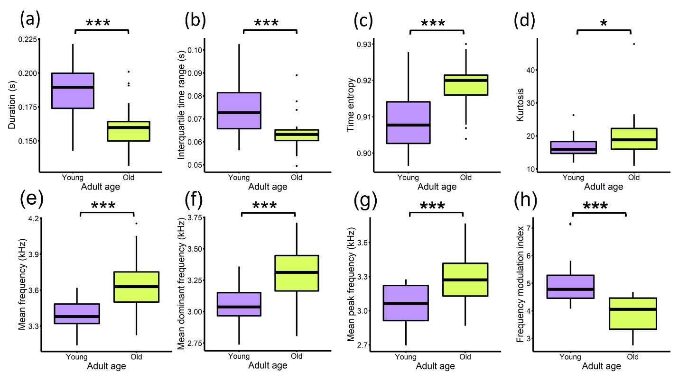
Figure S1. Contact call spectrographic parameters found to differ by adult age. ***P < 0.001; *P < 0.05.

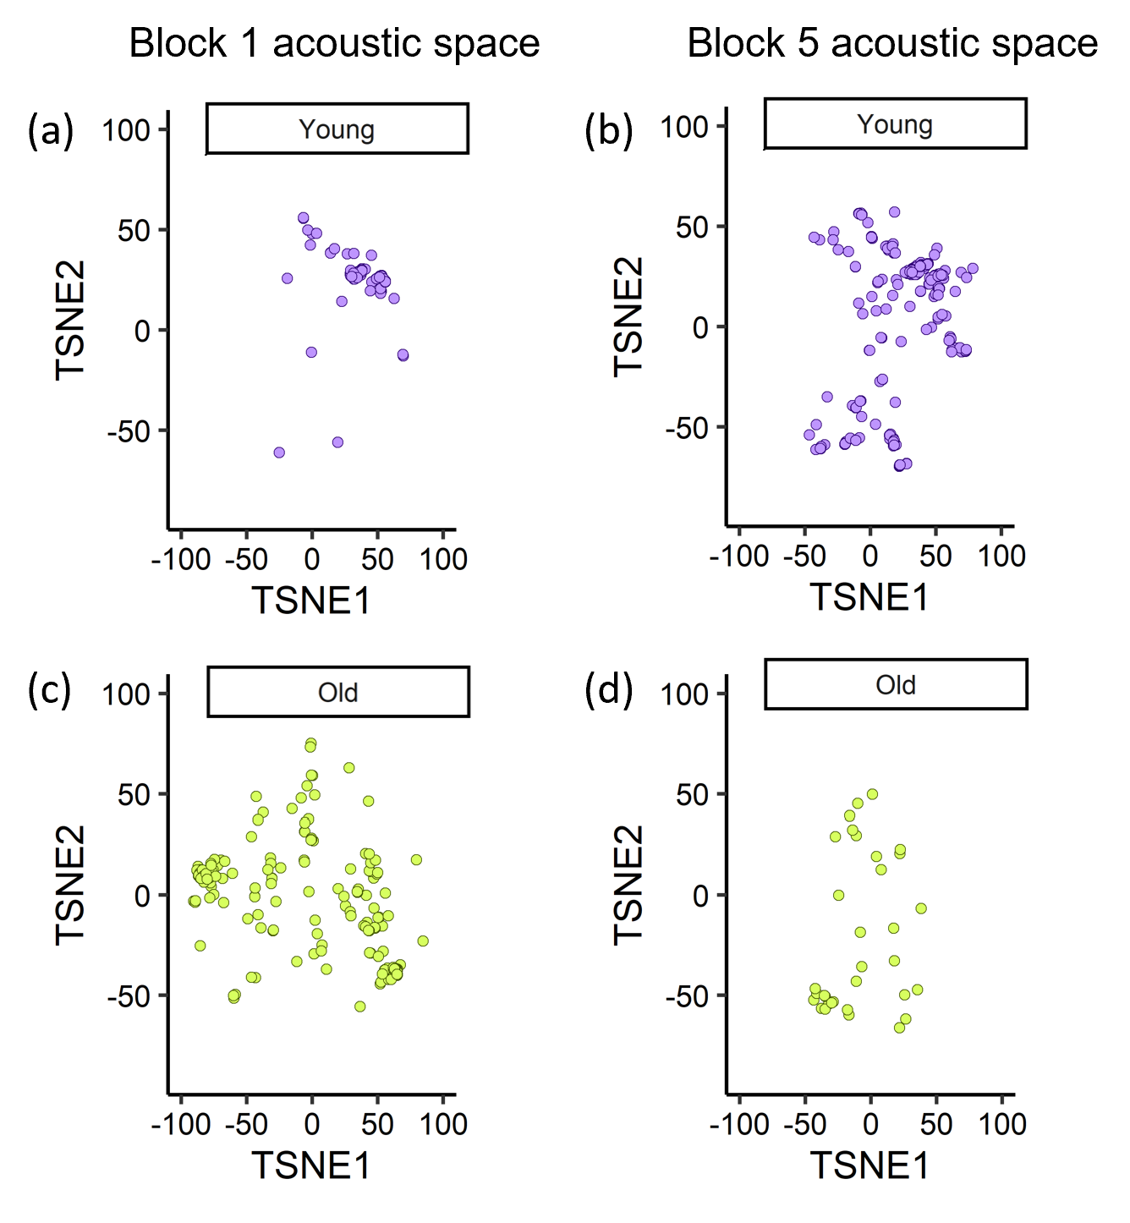
Figure S2. Contact calls projected into two-dimensional acoustic space using the t-SNE dimensionality reduction approach, where each point is a single call. Calls produced by a young adult in block 1 (a) vs. block 5 (b) and calls produced by an older adult in block 1 (c) and block 5 (d). These acoustic spaces are based on raw call numbers (without rarefaction) which reinforces our use of subsampling to generate acoustic spaces with equal call numbers.

- Social integration over time
When including the effect of time on social integration by comparing metrics computed for the first and second halves of recording, we find that social relationships change over time in similar ways for both adult age classes. For relationships defined by close proximity, density significantly increases over time for both young and older adult flocks, reflected by a significant effect of recording half (z = 2.534, p = 0.0113) (figure S3a). While connectivity based on proximity increased, the strength of connections remained stable over time for both young and older birds (figure S3b). Similarly, we find a significant increase in affiliative density (z = 3.875, p < 0.001) and strength (z = 7.156, p < 0.001) as well as agonistic density (z = 4.467, p < 0.001) and strength (z = 6.987, p < 0.001) (figure S3c-f). The interaction between recording half and age class was not significant for any model, indicating that both young and older adults show similar patterns of increased affiliative and agonistic social integration over time.

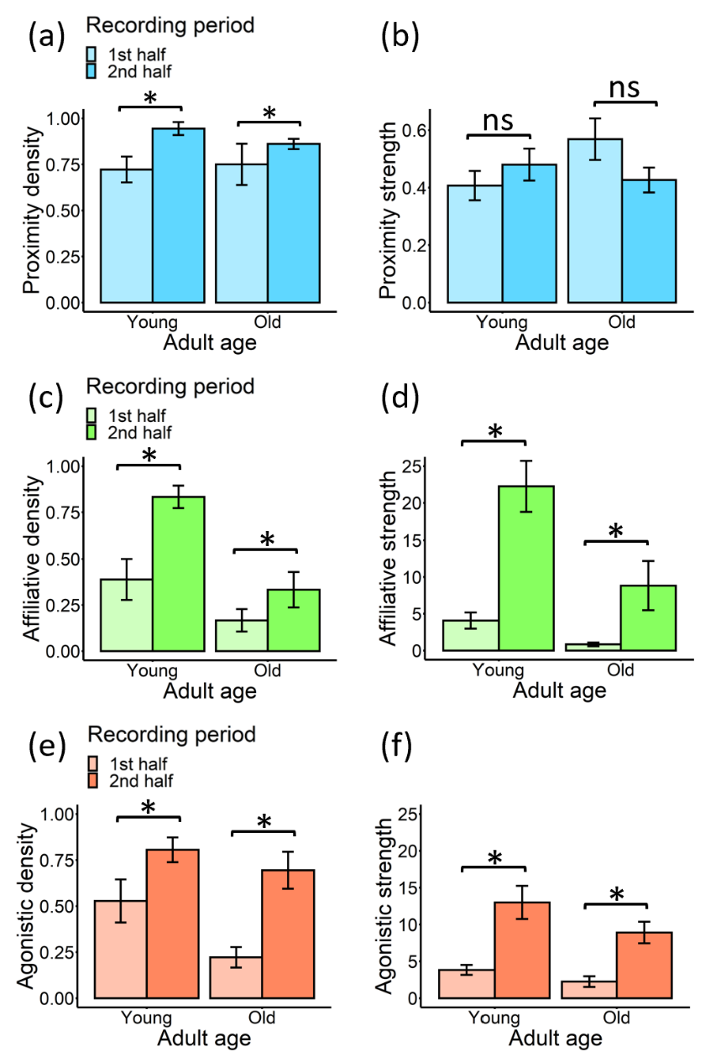
Figure S3. Change in social integration over time by adult age class. Mean ± SE proximity (a-b), affiliative(c-d), and agonistic (e-f) density and strength metrics computed from interactions subset by the first and second half of the video-recording period. *P < 0.05. ns = not significant.

